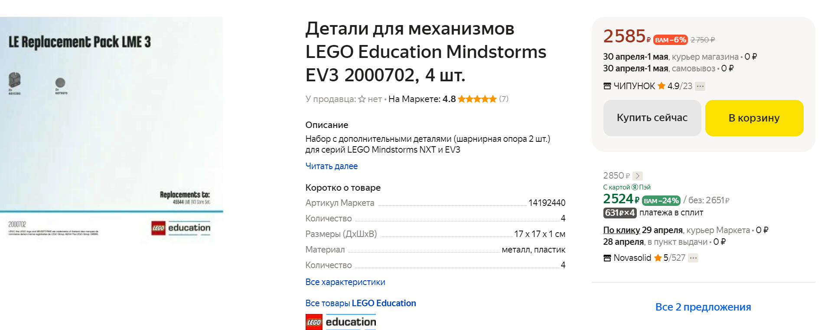
https://market.yandex.ru/product--mindstorms-ev3-2000702/1778200504?sku=14192440&do-waremd5=0-DnFw-IjMe6uu7x8qVZzA&uniqueId=17829587&cpc=nqGqAZgHSbJ9OZYXVa15WdW5Zl8KjYKmqo39tMiVKOP6CBdtE0dlSNf1sYOzHNBCU9_Vr4W1pUACRz01_Cxvj-WqM4H_ng7baUUAnz6KFOx6jbfp9XVg6hCbViNG3sZvTAYTEH_RYD7nBlwoMVyTK71lve3MzgNsoDAaijD0emW7nMDMY6fHKUTwOJQj2Yz7R0nWwMhV4UsYylvXNlmOiw%2C%2C
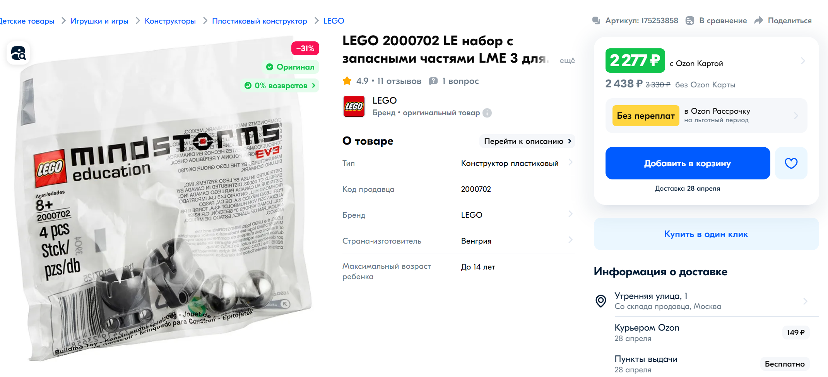
https://www.ozon.ru/product/lego-2000702-le-nabor-s-zapasnymi-chastyami-lme-3-dlya-mindstorms-ev3-175253858/?utm_medium=organic&utm_referrer=https%3A%2F%2Fyandex.ru%2Fproducts%2Fsearch%3Ftext%3D%25D0%2594%25D0%25B5%25D1%2582%25D0%25B0%25D0%25BB%25D0%25B8%2520%25D0%25B4%25D0%25BB%25D1%258F%2520%25D0%25BC%25D0%25B5%25D1%2585%25D0%25B0%25D0%25BD%25D0%25B8%25D0%25B7%25D0%25BC%25D0%25BE%25D0%25B2%2520LEGO%2520Education%2520Mindstorms%2520EV3%25202000702%252C%25204%2520%25D1%2588%25D1%2582&utm_source=yandex_serp_products
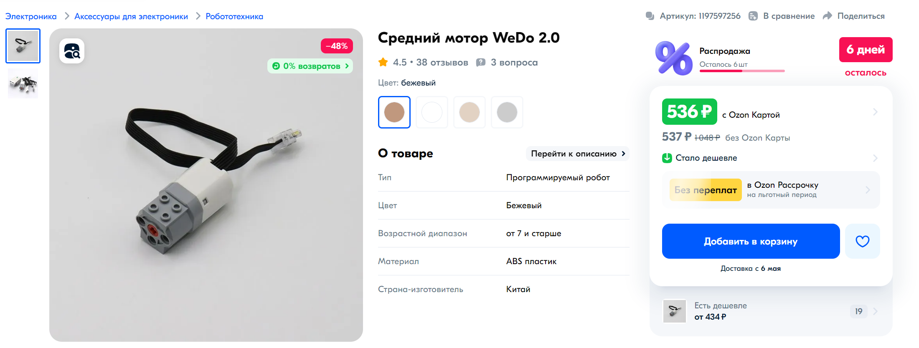
https://www.ozon.ru/product/sredniy-motor-wedo-2-0-1197597256/?utm_medium=organic&utm_referrer=https%3A%2F%2Fyandex.ru%2Fproducts%2Fsearch%3Ftext%3D%25D0%25B4%25D0%25B2%25D0%25B8%25D0%25B3%25D0%25B0%25D1%2582%25D0%25B5%25D0%25BB%25D1%258C%2520wedo%25202.0&utm_source=yandex_serp_products
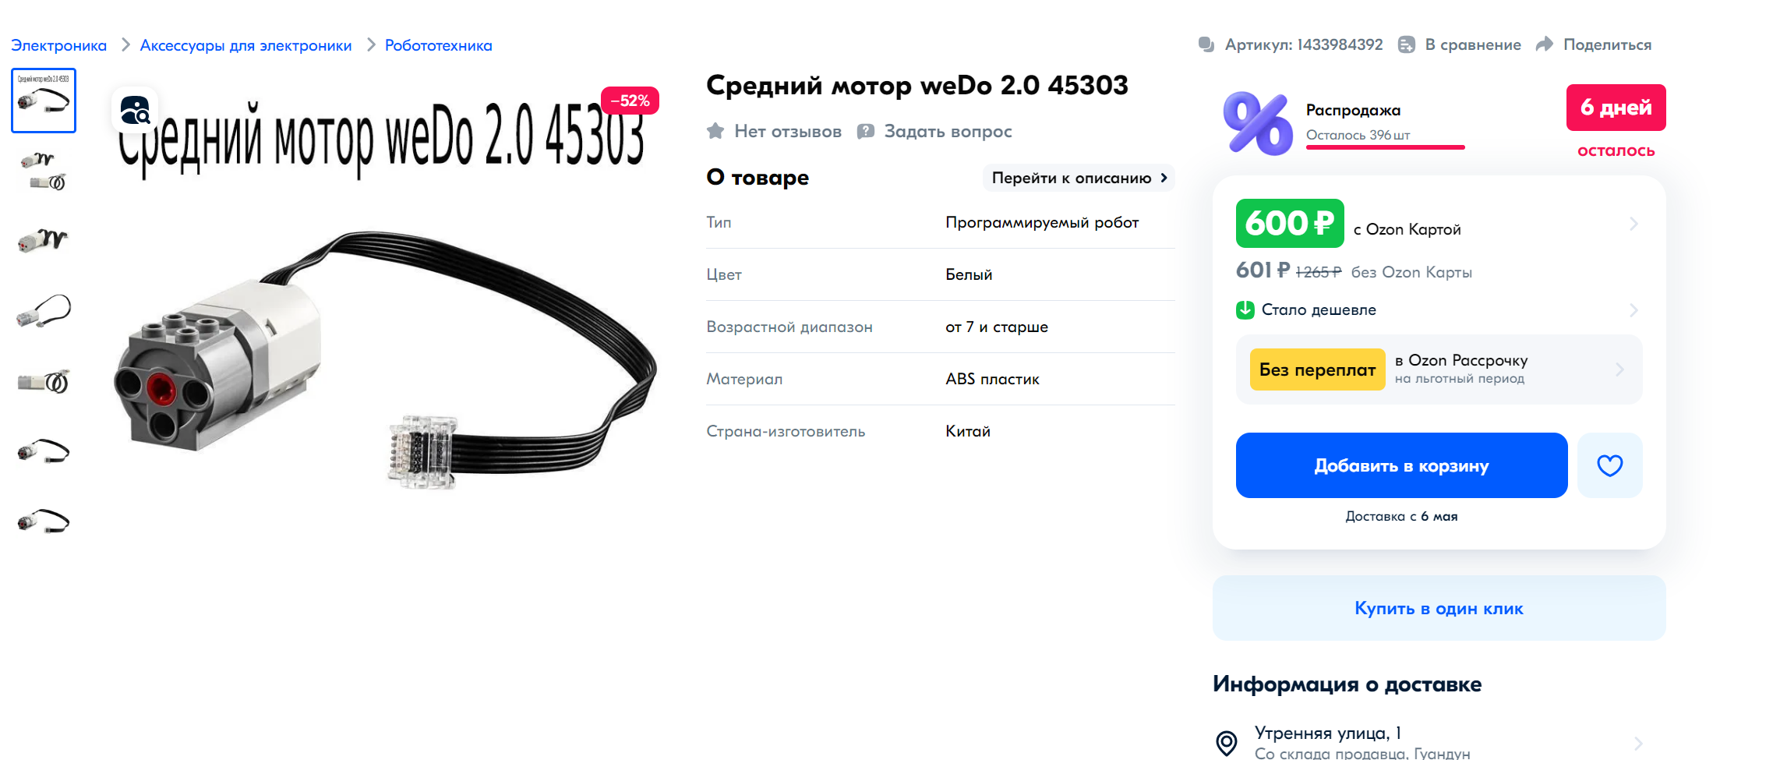
https://www.ozon.ru/product/sredniy-motor-wedo-2-0-45303-1433984392/?utm_medium=organic&utm_referrer=https%3A%2F%2Fyandex.ru%2Fproducts%2Fsearch%3Ftext%3D%25D0%25A1%25D1%2580%25D0%25B5%25D0%25B4%25D0%25BD%25D0%25B8%25D0%25B9%2520%25D0%25BC%25D0%25BE%25D1%2582%25D0%25BE%25D1%2580%2520WeDo%25202.0&utm_source=yandex_serp_products
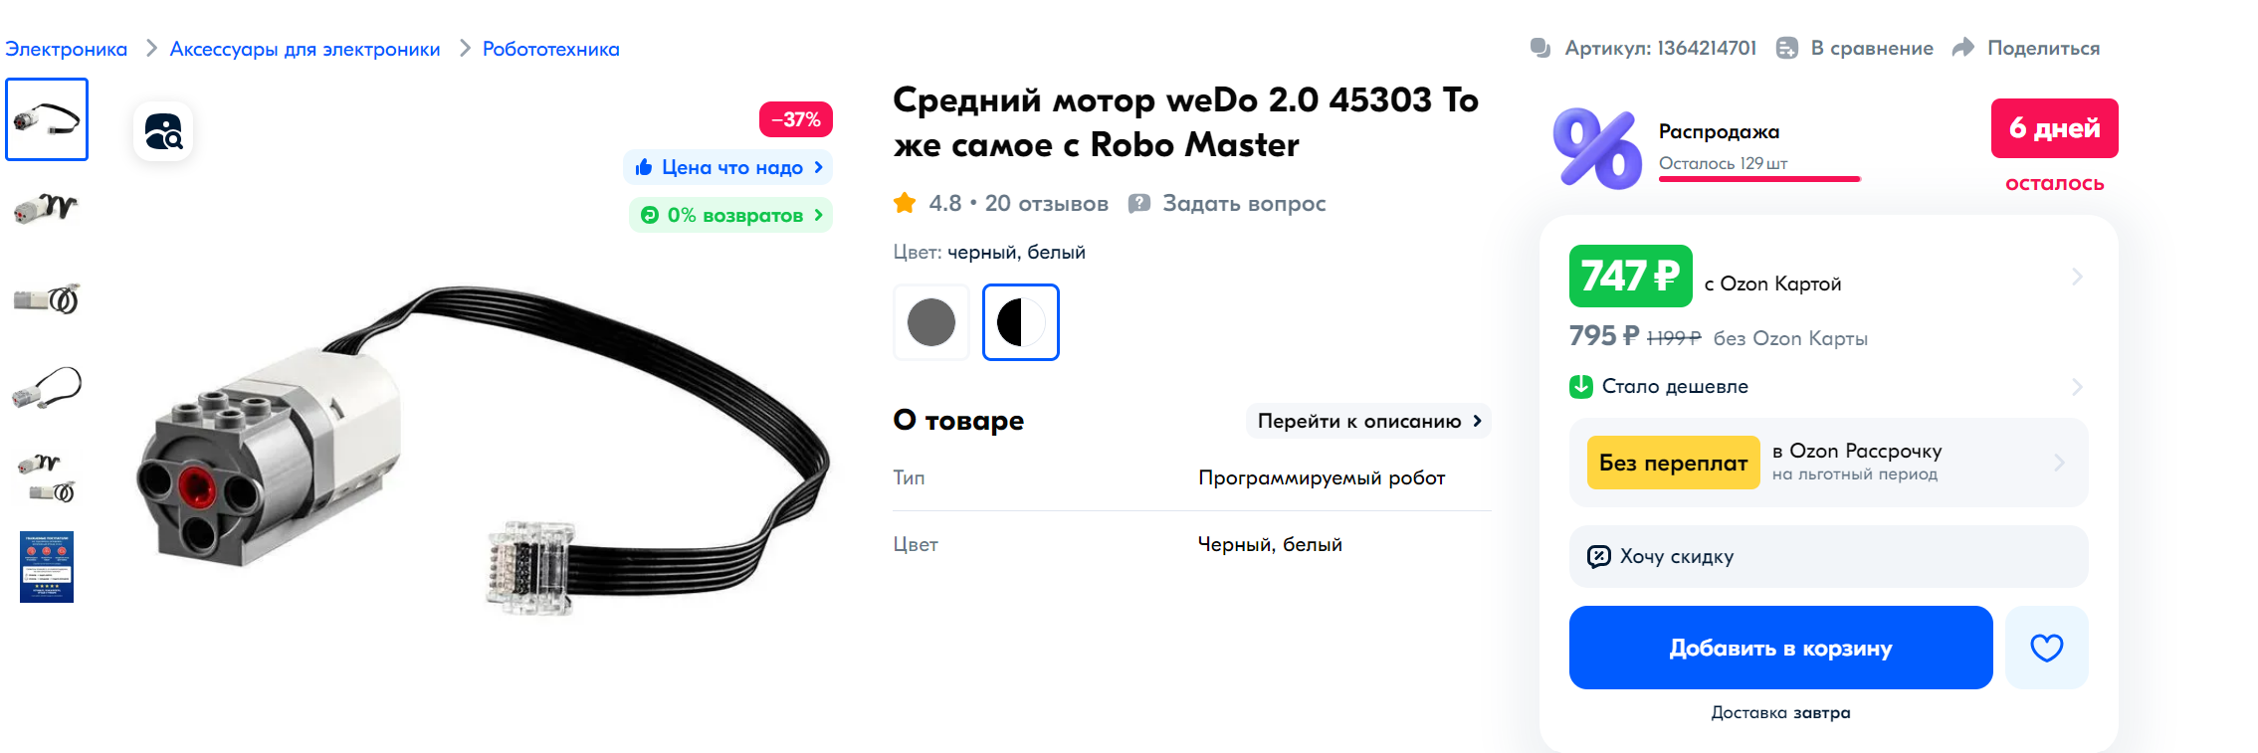
https://www.ozon.ru/product/sredniy-motor-wedo-2-0-45303-to-zhe-samoe-s-robo-master-1364214701/?asb=1RDPKGA4ukLuIflH%252B2MO7aWGp%252F3i3UFQJm94fU18kiM%253D&asb2=HHd7OZMnLynp3BqGvJQGXlws-k6zxM-SYSrF8VPq_YlFvDtzX4JUYuEcziDtTWUKZAFux-M4uNro7tyNKj-jjA&avtc=1&avte=2&avts=1714039148&keywords=Средний+мотор+weDo+2.0+45303
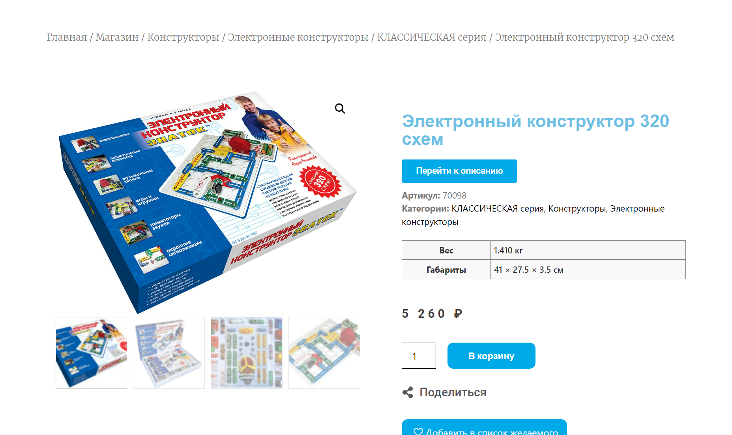
https://znatok.ru/shop/konstruktory/znatok-electronniy-constructor/numernaya-seriya/znatok-320/
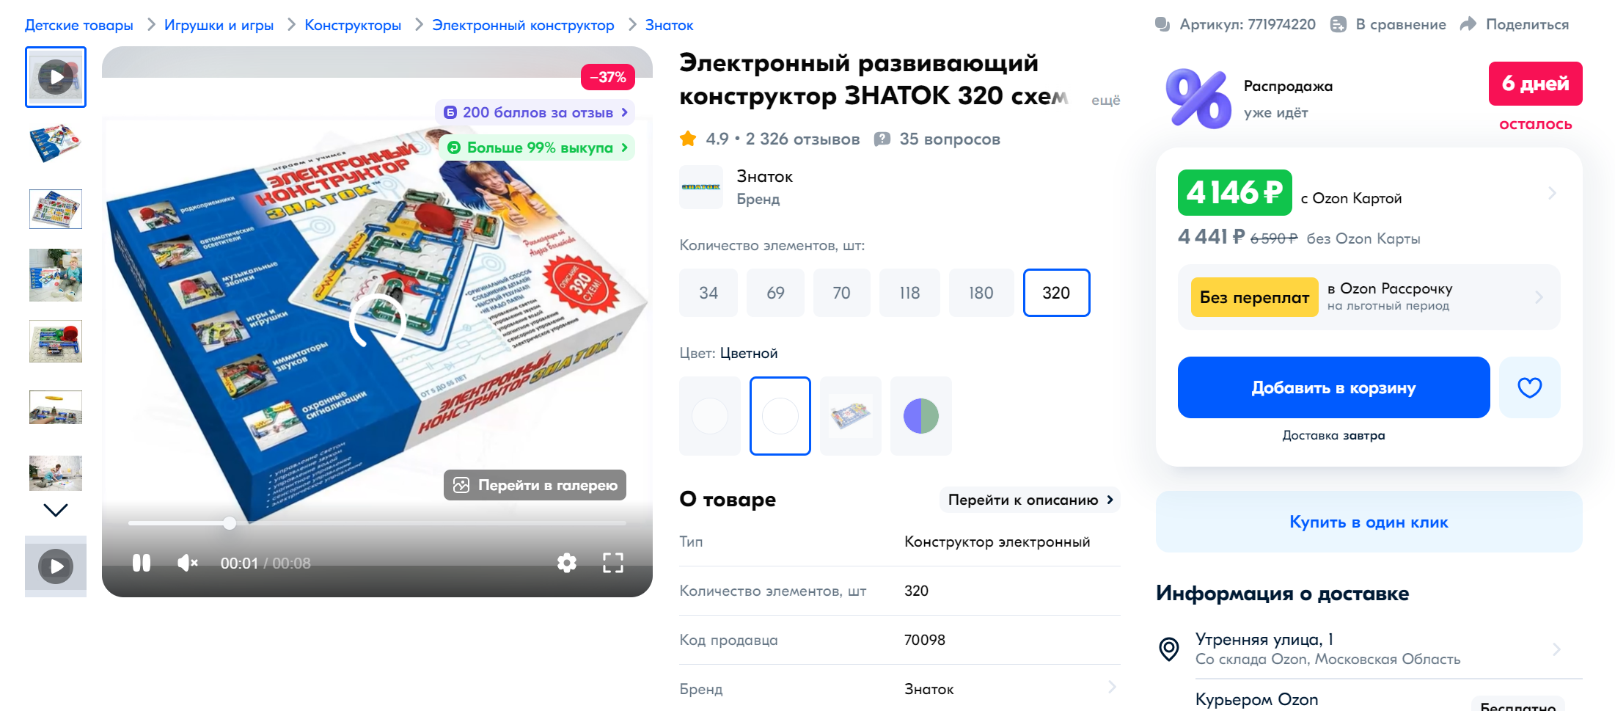
https://www.ozon.ru/product/elektronnyy-konstruktor-znatok-320-shem-771974220/?utm_medium=organic&utm_source=yandex_serp_products
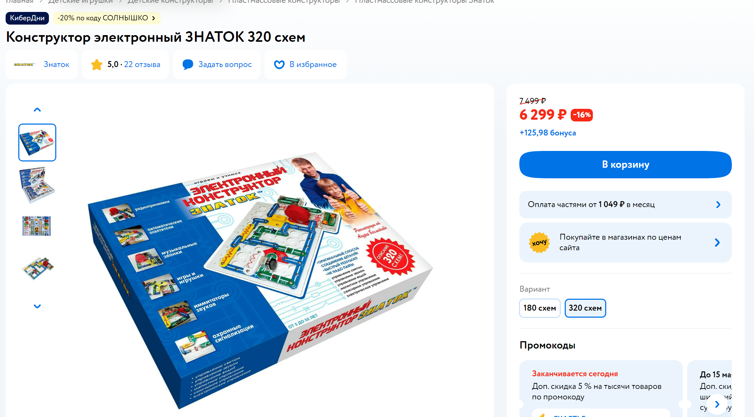
https://www.detmir.ru/product/index/id/3448381/?utm_source=yandex&utm_medium=tovarnaya_galereya

